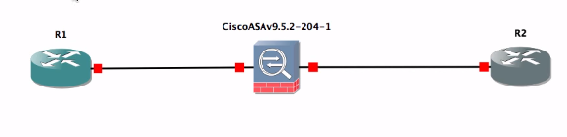

============================

Cisco ASAv configuration:

============================

interface GigabitEthernet0/0

nameif outside

security-level 0

ip address 8.8.8.254 255.255.255.0

no shut

!

interface GigabitEthernet0/1

nameif inside

security-level 100

ip address 10.1.1.254 255.255.255.0

no shut

route outside 0.0.0.0 0.0.0.0 8.8.8.8

object network obj_any

subnet 0.0.0.0 0.0.0.0

nat (inside,outside) dynamic interface

policy-map global_policy

class inspection_default

inspect icmp